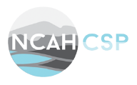

The NCAHCSP Chapter is pleased to invite you to attend a FREE upcoming Virtual Webinar sponsored by Healthmark Industries to be held Saturday, December 5th from 8am to 3pm EDT. Please register below in the following link provided. You will receive 6 Hour CEUs good for IAHCSMM, CBSPD, Nursing, and CBIC for IP Professionals. If attendees want to get together in a group in one location to watch the webinar, please email crojo@hmark.com to receive a special sign-in sheet.

Click Link to Register:
https://attendee.gotowebinar.com/register/5591006042217421072

After registering, you will receive a confirmation email containing information about joining the webinar. If you are using a work email, there may be security or policy restrictions from your facility restricting outside emails and you may have to use your personal email. You may want to look in your “Junk Email” folder, since confirmation emails can end up there.
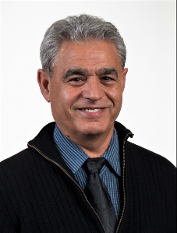
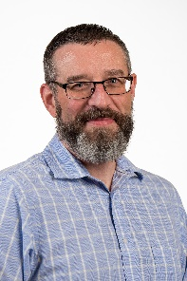
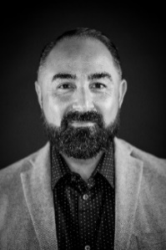
Healthmark Presenters:
Cheron Rojo, Clinical Education Coordinator
Seth Hendee, Clinical Education Coordinator
Jahan Azizi, Special Projects Manager

Agenda:

- 8am to 9am "Attitude Touches Everything, But Should it?" Cheron Rojo
- Understand and define the power of attitude “Bad or Good”, the ABC’s, and how attitudes are learned
- Identify behaviors from an attitude and the different types of behaviors
- How to maintain a positive attitude
- Describe attitude of gratitude
- 9am to 10am " Bridging the Gap Between BioMed & CS" Jahan Azizi & Seth Hendee
- Describe the complexity of medical devices and accessories
- Describe Biomed roles in medical devices management
- Describe SPD role in processing accessories essential to medical devices function

Break 10am to 10:15am

- 10:15am to 11:15am "C.H.I.P. Tips (Care, Handling, Inspection, & Prevention) Decontamination Edition" Cheron Rojo
- Review sterile processing tips in everyday tasks in the decontamination area
- Understand the importance of handling instrumentation and equipment within your department on the decontamination side
- Reinforce the basic technical principles that are used in the decontamination area
- Understand the impact that standards and guidelines have in a properly functioning department within decontamination area that processes instrumentation and medical devices.
- 11:15am to 12:15pm "Optical Visual Inspection of Medical Devices" Seth Hendee
- Define optical inspection
- Review the benefits of optical inspection of medical devices
- Review various methods for optical inspection
- Demonstrate examples of inferior cleaning exposed with the use of optical inspection

Lunch: 12:15pm to 12:45pm

- 12:45pm to 1:45pm " Understanding Communication & Human Relations in the Workplace" Cheron Rojo
- Review communication types and interpersonal styles in the workplace
- Discuss the types of communication walls and barriers that inhibit effective communication
- Define injustice collecting and crucial conversations and types of confrontation
- Discuss the types of storytelling and the managing of rumors

Break: 1:45pm to 2pm

- 2pm to 3pm " The Art of Brushing; You Are an Artist!" Seth Hendee
- Review steps needed to pick a brush to clean any medical device and vital skills and techniques to clean any medical device
- Discuss anatomy of a brush and selecting the correct brush from your inventory
- Identify the medical device to be cleaned and then examine the medical device to understand what you must clean
- Understand the IFU for any specific brushes and the use of standards and guidelines when IFUs are vague

